Note Three

* **Confidence Intervals**
  + A 95% confidence interval for µY is an interval that contains the true value of µY in 95% of repeated samples.
  + For r.v Y which has only 1 or 0.
    - E(Y) = p
    - var(Y) = p(1 - p)
* **Hypothesis Testing**
  + H0 : E(Y) = uY
  + H1 : E(Y) ≠ uY
  + p-value
    - Calculation
    - 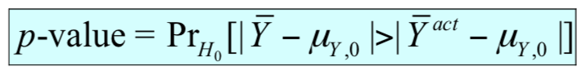
    - 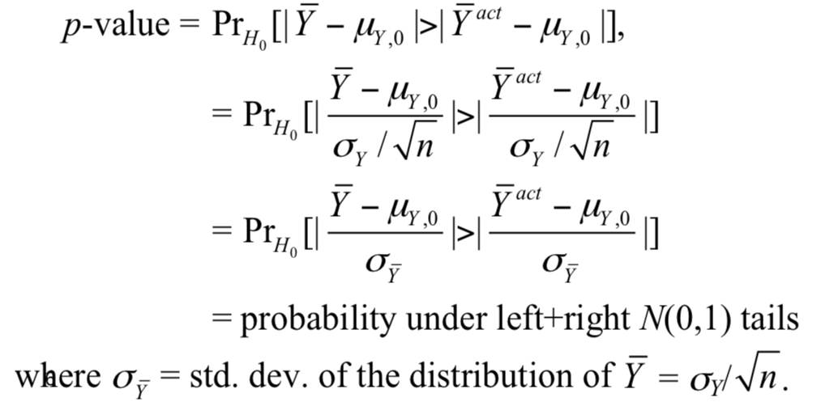
    - Link between p-value and the significance level
      * If the significance level is 5%
        + Reject the null hypothesis if |tact| ≥ 1.96
        + Reject if p ≤ 0.05
  + **t-table and degrees of freedom**
    - Degrees of freedom = n - 1
    - 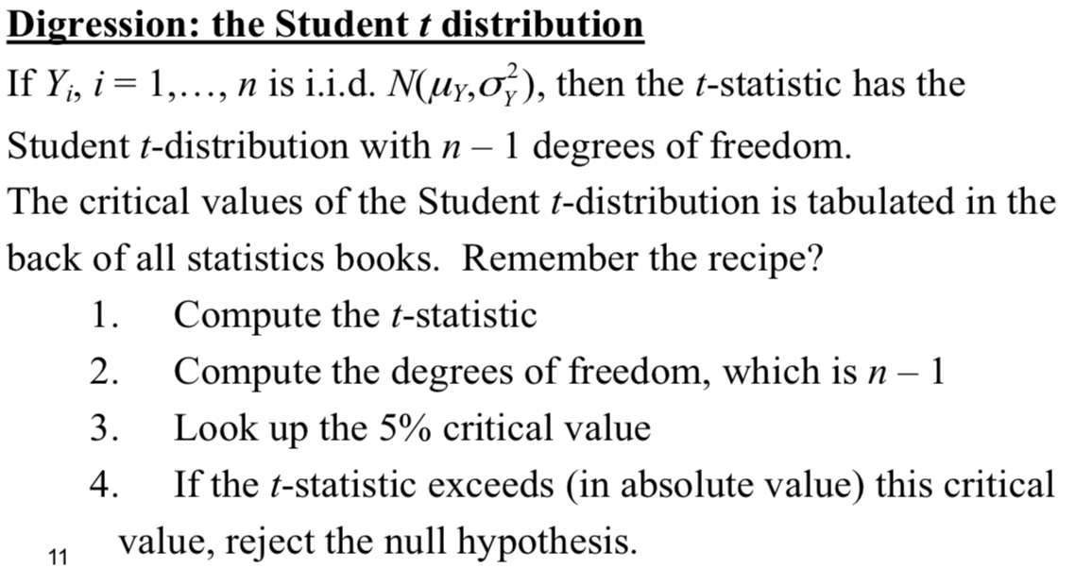
    - T table is typically used when the sample size is small. (**n < 30**)